Effects of the spatial distribution of the spin-wave signal power in YIG waveguides
Masliy R.V.¹, Khutieva A.B.¹, Sadovnikov A.V.¹
¹Saratov State University, 410012, Saratov, Russia

At present, methods for constructing information signal processing systems based on the effects of the transfer of magnetic moments or electron spins without charge transfer are being actively studied [1]. In such devices based on magnon principles, the information signal is encoded in the phase or amplitude of spin waves (SW), and logical operations are implemented based on the principles of spin-wave interference [2]. Planar ferrite waveguide microstructures of finite width based on yttrium iron garnet (YIG) films can be used as the basic elements of "magnon networks" to create various signal processing devices: delay lines, filters, interferometers, switches, multiplexers [3-4].
In this work, we study the influence of the dipole coupling of magnon microwave guides for the implementation of vertical and lateral transport of magnons. To study the dynamics of SW propagation in a system of YIG waveguides, the method of coupled waves was used [5–6]. With the help of micromagnetic modeling, the modes of SW propagation in arrays of microwave guides formed by an array of YIG strips were studied [7]. The mechanisms leading to the formation of various "patterns" formed by a spin-wave signal during its propagation in longitudinally irregular thin-film magnon microwave guides are investigated.

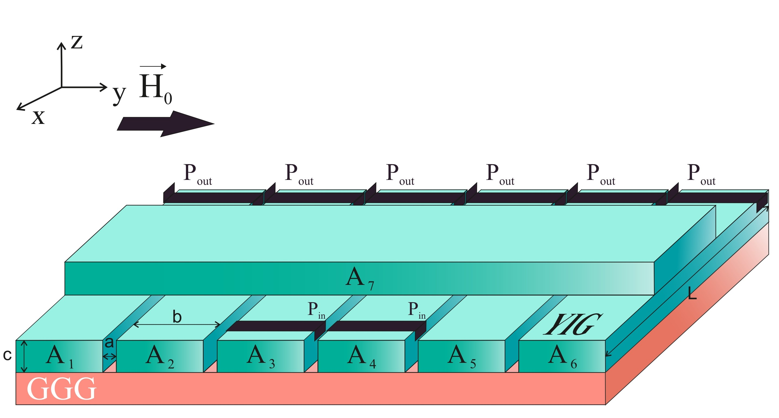
Fig. 1. Schematic representation of a microwave guide array, a – horizontal gap, b – width, c – thickness, L – length of the microwave guides, P_{in} and P_{out} – microstrip antennas for excitation and reception of SW, respectively.

Micromagnetic modeling [8] was carried out for a system of laterally and vertically coupled ferrite microwave guides (Fig. 1) made of an yttrium iron garnet film, located on a gallium gadolinium garnet (GGG) substrate. Microwaveguides are made in the form of elongated strips, length L = 4 mm, width b = 300 μm and thickness c = 10 μm, forming a grating of a horizontal layer, which contains six waveguides located with gaps in the horizontal plane, and one waveguide located perpendicular to them. The saturation magnetization of yttrium iron garnet films is М = 139 Gs, and the value of the external magnetic field is H₀ = 1200 Oe directed along the y axis, which ensures effective excitation of surface spin waves (SSWs). The radiative damping of weak modes differs from the damping of strong modes by two orders of magnitude, which makes it possible to reduce the amount of pumping required to enter the lasing regime. The pump value can be reduced, practically, to the level of compensation for dissipative losses. The decay frequency of weak modes is about 0.0005 THz, while the decay frequency of strong modes is about 0.08 THz. The amplification mode requires compensation not only for dissipative losses, but also for radiation losses. Thus, a decrease in radiative damping substantially lowers the lasing threshold.
The work was supported by the Russian Science Foundation
(project №20-79-10191).

References
[1] N.P. Author1, Phys. Rev. A 70, 013603 (2004).
[2] N.P. Author1 and N.P. Author2, e-print arXiv:0704.3011 (2005).
[3] N.P. Author1, N.P. Author2, and N.P. Author3, Phys. Rev. A 70, 013603 (2004).
[4] N.P. Author1 and N.P. Author2, Book Title (Publisher, City, 2007).

[1] A. Barman, G. Gubbiotti, S. Ladak, J. Phys.: Condens. Matter. V. 33. N. 41. 413001 (2021).
[2] D. D. Stancil, A. Prabhakar, Springer (2009).
[3] Q. Wang, P. Pirro, R. Verba, S. Adv. 4, e1701517 (2018).
[4] K. Vogt, H. Schultheiss, S. Jain, Appl. Phys. Lett. 101, 042410 (2012).
[5] A. B. Khutieva, B. R. Akimova, E. N. Beginin, A. V. Sadovnikov, Phys. Sol. St. V. 9, 1279 (2022)
[6] A. B. Khutieva, E. N. Beginin, S. E. Sheshukova, A. V. Sadovnikov, Phys. Sol. St. V. 14, 2344 (2022).
[7] A. B. Khutieva, B. R. Akimova, E. N. Beginin, A. V. Sadovnikov,
[8] A. Vansteenkiste, J. Leliaert, M. Dvornik, AIP Adv. 4. 2014. 107133.

