Study of in Situ Pain Relief and Personalized Treatment of PDT

Dongqin Lei¹, Rongrui Zhng¹, Jing Wang¹, Weihui Zeng² and Cuiping Yao^{1*}

¹School of Life Science and Technology, Xi’an Jiaotong University, China
² The Second Affiliated Hospital, School of Medicine, Xi’an Jiaotong University, China
zsycp@xjtu.edu.cn

Abstract
Photodynamic therapy has been used for treatment of port wine stains in clinic, which has a good outcome, especially for children. However, the pricking and burning sensation during photodynamic therapy is very acute, which is hard to bear for children and prevent coorperation. In addition, multiple treatments were needed for most patients. Memories of pain can impose a netative physiological or psychological effects on children. These disadvantages limit the use of PDT for port wine stain. Therefore, managing patients’ pain during PDT is a very important challenge that clinicians must face. In some studies general anaesthesia was emplyed during PDT. However, there is no consensus on the best anaesthetic techniques to use when performing PDT for PWS [1]. The safety and efficiency of general anaesthesia should be further assessed. Here we have developed an in situ anaesthesia strategies, in which a nanostructure was designed to encapsulate the photosensitizer and lidocaine, a kind of local anesthetic, for medicine delivery and in situ releasing. For assessment of the pain relief of the pain during photodynamic therapy, the xenografted tumor of melanoma treatment was used to mimic port wine stain treatment due to the abnormal and abundant blood vessel in tumor. For experiments, the nanostructures were intravenously injected into melanoma tumor-bearing mice, in vivo fluorescence images showed that the photosensitizer could enormously accumulate at the tumor site. Electrophysiological experiment was used to prove the effectiveness of pain relief by using nanostructure during PDT as shown in figure 1, and the amount of expression of pain-related proteins further confirmed the results. The in vitro and in vivo anti-tumor results revealed excellent photodynamic efficacy. Therefore, such anesthetic in situ released nanostructure with photosensitizer might provide a promising new strategy for pain relief during PDT as well as enhance PDT efficacy. Furthermore, a method for measuring pain during PDT through electrophysiological experiments has been proposed for the first time. On the other hand, an so different outcomes were observed for different people with same parameters such as light intensity, concentration of photosensitizer in clinic, which should be relative to the personalized factors such as photosensitizer accumulation, locally blood oxygen and so on. To realize the personalized treatment of the PDT, using animal model, a hyperspectral imaging system was build based on a liquid crystal tunable filter. By combining wide-field spectrally resolved fluorescence imaging with a dual-band fluorescence spectral correction algorithm, we achieved quantitative detection of photosensitizer concentration. Also multispectral imagings were used to determin tissue oxygen saturation by calculating the absorption difference of hemoglobin. Base on these information, narrow-band optical imaging was emoloyed to calculate changes in target vessel diameter for quantitative assessment of photodynamic damage. The experimental results demonstrated the effective detection of each dose parameter in PDT using the hyperspectral system, enabling the prediction of treatment outcomes. we expected that these results could be useful for devepment of the persenalized treatment.

(a) | 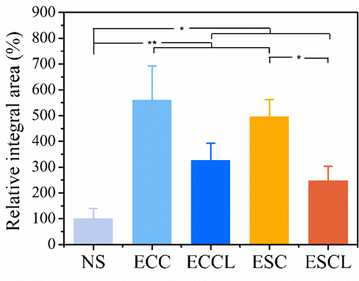(b)

Figure: (a) The electrophysiological recordings of the sciatic nerve of mice after being treated by the micelles under 660 nm laser (960 mW cm-2) illumination in 5 min (b) The relative integral area of the neural signal

References
- Linlin Tang, Wei Liu, Qian Yu, Hongjie Guo, Xue Yang and Ling Xiong, General anaesthesia for photodynamic therapy of port-wine stain in children: A retrospective study, Photodiagnosis and Photodynamic Therapy, 41, 103273, 2023,

